Smart Card Distribution System

Home page:

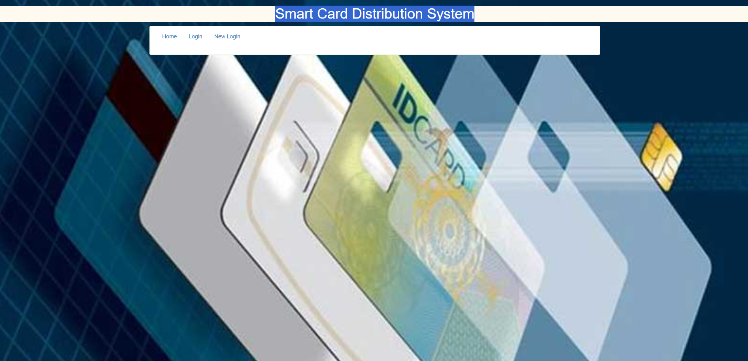

Login page:

Login Register Page:

Card holder list page:

Smart card registration page:

Update page:

Distribution page:  
